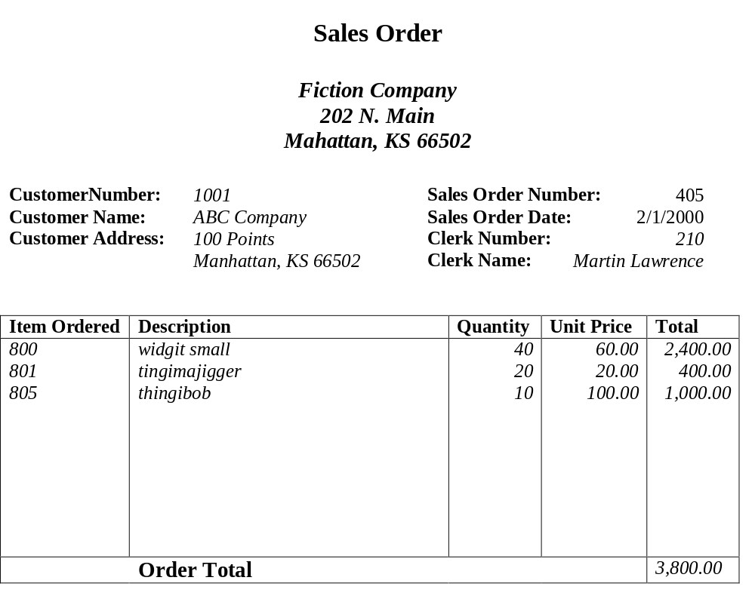
Example1:

Primary Key: Sales Order Number

Problem1 solution

Sales(cust_num,cust_name,cust_address,sales_num,sales_date,
clerk_num,clerk_name,item_order,description,quantity,unit_price,ordertotal)

1st NF

Sales (cust_name, cust_num, address, sales_num, sales_date, clerk_num, clerk_name)
Item (sales_num, item, description, quantity, unit_price, Total)

2st NF

Sales (cust_name, cust_num, address, sales_num, sales_date, clerk_num, clerk_name)

Item (sales_num, item, quantity)

Item_Desc(item,Description, Unit_Price)

3st NF

Sales(sales_num, cust_num, sales_date, clerk_num)

Customer(cust_num, cust_name, address)

Clerk(clerk_num, clerk_name)

Item(sales_num,item,quantity)

Item_Desc(item,description,unit_price)

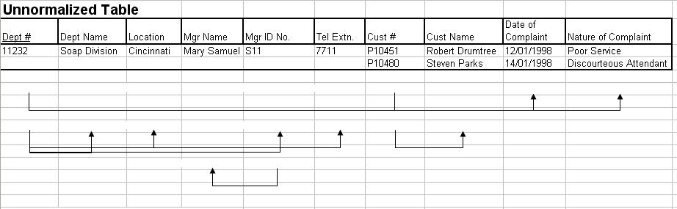
Example2:

Problem 2 solution

Company(dept_num, dept_name, location, mgr_NAME, mgr_ID, cust_name, cust_num_date, nature, tel)

1st NF

Company(dept_num, dept_name, location, mgr_NAME, mgr_ID, tel)
Customer(dept_num, cust_name, cust_num_date, nature)

2st NF

Company(dept_num, dept_name, location, mgr_NAME, mgr_ID, tel)
Customer(dept_num, cust_num, date, nature)
Customer_Name(cust_num, cust_name)

3st NF

Company(dept_num, dept_name, location, mgr_ID, tel)
Customer(dept_num, cust_num, date, nature)
Customer_Name(cust_num, cust_name)
Manager(mgr_ID, mgr_NAME)

